Practical Application of PaaS with Railway - Event Scheduler
Student Name: Mukyala Dorcus Nandy
REG N0. 23/U/11911/EVE
Student N0. 2300711911
Submission Date: April 3, 2026
App URL: https://web-production-0edef.up.railway.app/
GitHub Repo: https://github.com/MukyalaDorcusNandy/event-scheduler

1. Deployment Process
1.1 Application Overview
I built an Event Scheduler web application using Python Flask. The app allows users to:
- View all upcoming events
- Add new events (Create)
- Edit existing events (Update)
- Delete events (Delete)
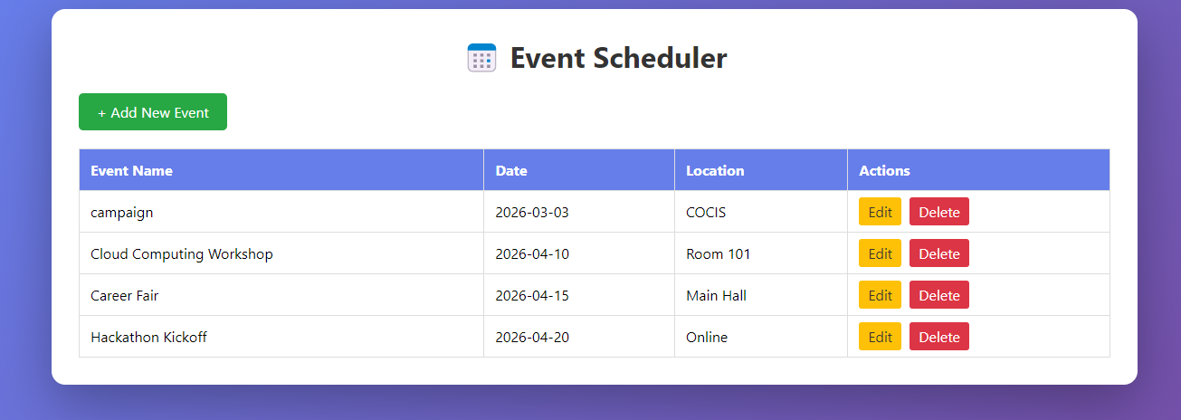
Figure 1: Event Scheduler running locally on http://localhost:5000 showing the main interface with existing events
1.2 Deployment Steps
- Created Flask application with SQLite database
- Pushed code to GitHub repository
- Created Railway account and connected GitHub
- Deployed app from GitHub repository
- Generated public URL

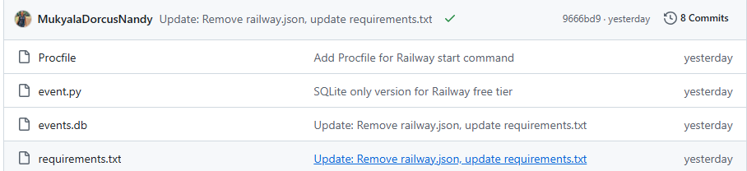
Figure 2: GitHub repository showing all project files including event.py, requirements.txt, and commit history.

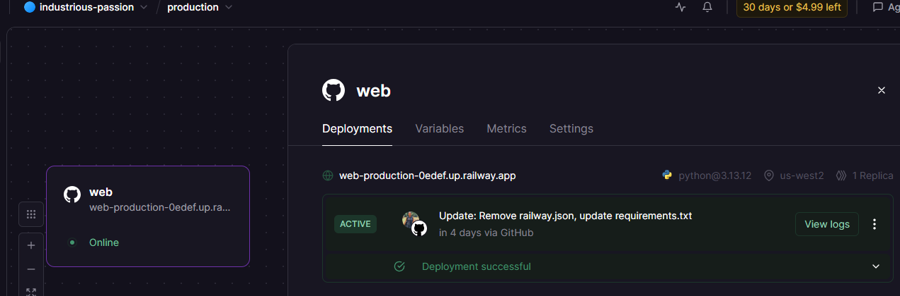
Figure 3: Railway dashboard showing successful deployment with "ACTIVE" status and live URL.
2. Environment & Configuration Management (15%)
2.1 Database Path Configuration
I used environment-based configuration to handle different paths:
- Locally: Uses “ events.db ” in current directory
- Railway: Uses “ /tmp/events.db ” (Railway's writable location

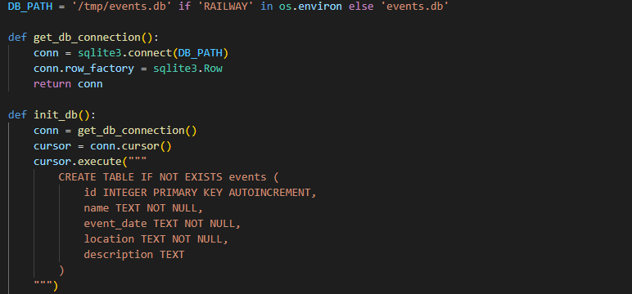
Figure 4: Database path configuration showing conditional logic for local (/events.db) vs Railway (/tmp/events.db) environments.

2.2 Dependencies Management
I Created requirements.txt:

2.3 Start Command
Then Created Procfile to tell Railway how to start the app:
3. Database Integration

